# 9 Men’s Morris Project Report

**What is 9 men’s morris?:**

It is an ancient 2 player strategy board game consisting of three concentric squares, connected by the middles of each of the inner square’s sides to the middle of the corresponding outer square’s side.

Pieces are played on the corner vertices. Meaning there are 24 playable points.

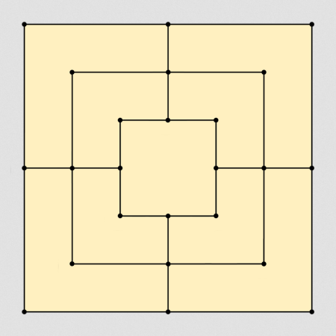

Both players try to form ‘mills’ (three of their pieces in a straight line). A mill allows them to remove an opponent piece from the game. A player wins when their opponent has only 2 pieces left, or by leaving them without any possible moves.

There are 3 phases to the game:

1. Placing pieces on vacant points (9 turns each)
2. Moving placed pieces to adjacent points.
3. Moving pieces to any vacant point (when the player has been reduced to 3 men)

**My approach:**

I have created 2 heuristics to have the AI learn how to play the game.

1. Number of Pieces: The higher the difference in the number of pieces of player 1 and player 2, the better.
2. Number of potential mills: The higher the number of mills potentially formed, the better.

Heuristic #2 performs much better than heuristic #1.

Important utility functions have been placed in utils.py and are imported by the three files used to play the game.

It can be run in 3 modes:

1. Human vs. human
2. Human vs. AI
3. AI vs AI

**Human vs. Human:** In this mode, two humans can play against each other. Normal rules are followed, and heuristic algorithms are not applied.The first player to have 2 pieces remaining or to run out of moves loses.

**Human vs. AI:** This mode pits a human vs our AI. You can use two types of heuristic algorithms here. One uses number of remaining pieces as the basis for learning, and the other uses number of possible Mills formed as its factor. We can choose either one of the algorithms for the AI and the game will start. The AI is fully functional and can create mills, remove pieces etc. The AI performs decently.

**AI vs AI:** Here two AIs using two different heuristic algorithms are placed against each other. We find that the number of possible mills formed heuristic algorithm performs better than the number of remaining pieces heuristic algorithm, as it is more complicated and takes the objective of the game more seriously and to the point.